The Architecture of Cinematic Meaning: Narrative Syntagms, Cineosis, and the Operative Execution of Visual Media
The construction of meaning within visual media represents one of the most complex intersections of art, linguistics, philosophy, sociology, and computer science. The evolution of the moving image—from a sequence of structured narrative shots designed for human emotional engagement to an autonomous system of algorithmic machine vision—demands a multifaceted analytical approach. Cinematic meaning does not emerge organically from the ether; it is deliberately engineered through rigid syntactic structures, semiotic sign systems, socio-political narrative frameworks, and, increasingly, computerized visual execution.¹
By tracing the trajectory of filmic language across these disparate disciplines, one observes a profound paradigm shift in how human civilization records, interprets, and interacts with reality. Initially, mid-twentieth-century structuralists sought to understand how the sequential arrangement of specific visual events creates a legible "world" for the human observer, grounding their theories in linguistics and structural anthropology.¹ Subsequently, post-structuralist philosophers pushed beyond mere linguistic comparisons to conceptualize cinema as an independent apparatus of thought—a domain of "cineosis" capable of synthesizing time and movement outside of standard human perception.⁵ Simultaneously, mass communications and media conglomerates co-opted these cinematic tools to translate chaotic global events into digestible, serialized geopolitical and cultural sagas, fundamentally altering the public's consumption of truth.²
Ultimately, this historical and theoretical trajectory arrives at the present era of the "operative image"—a visual execution divorced entirely from human aesthetic appreciation, functioning purely as a machinic tool of automation and control.⁴ This concept, while seemingly contemporary, was foreshadowed by the earliest experiments in programmable computer animation in the 1960s.³ This comprehensive report provides an exhaustive examination of these intersecting domains, dissecting the syntagmatic structure of narrative cinema, the philosophical semiotics of the Deleuzian taxonomy of images, the socio-political framing of the global media saga, and the technical reality of algorithmic visual execution.

The Semiotics of Sequence: Christian Metz and the Structuralist Approach
To understand how visual media constructs coherent narratives out of disparate world events, one must first dismantle the mechanics of the filmic sequence. In the mid-twentieth century, the application of linguistic theory to cinema birthed the rigorous field of film semiotics. Prior to this, film criticism was abundant, but almost nothing had been accomplished regarding the scientific study of film as a specific communication medium.⁸ Early theories were largely divided between Andre Bazin’s phenomenological tradition—which emphasized the camera's ability to capture an objective, unbroken reality—and Sergei Eisenstein’s formalist theories of montage, which argued that meaning was created through the collision of juxtaposed images.⁹
Operating within this theoretical landscape, French linguist Christian Metz sought to map the definitive "deep structure" of narrative cinema.¹ Metz utilized Saussurean linguistics as a point of departure, recognizing that while a film is an illusion, it is undeniably successful in seducing the spectator into suspending disbelief.⁸ Structuralists of the era often began their analyses by identifying the most basic units of meaning in narrative texts. For example, Tzvetan Todorov developed a framework dividing narratives into a transition from equilibrium, through disequilibrium, to a new equilibrium, while Claude Lévi-Strauss focused on the binary oppositions within cultural myths, terming the fundamental, recurring themes "mythemes".¹
Metz, drawing on these structuralist foundations, operated under the fundamental premise that a film's narrative is, at its core, a sum of sequenced events.¹ He posited that the language of cinema could not be conveniently treated if one adhered strictly to the definition of spoken or written language.⁹ Unlike written text, where a word serves as a highly conventionalized "knot" of meaning that anchors the horizontal flow of language, a filmic image initially appears as an analogue of reality, seemingly devoid of arbitrary, rule-based syntax.⁸ Because the cinematic signifier and signified appear to be one and the same, Metz initially stated that the "cinema is a language without signs".⁹ However, Metz recognized that a single shot's specific meaning is highly contingent; its true semiotic value is derived almost exclusively from its relationship to the shots preceding and succeeding it.¹ This relational meaning-making relies on the syntagm—the arrangement of interacting signs into a cohesive sequence.¹ This phenomenon is historically rooted in the Kuleshov effect, which demonstrated that audiences derive more meaning from the interaction of two sequential shots than from a single shot in isolation.¹

The Grande Syntagmatique: Eight Autonomous Segments
To systematize the construction of cinematic meaning, Metz developed la grande syntagmatique (the grand syntagmatic chain) in his early work, notably applying it to an analysis of Jacques Rozier’s 1961 film Adieu Philippine.⁹ This taxonomical framework identifies eight specific types of "autonomous segments" that filmmakers utilize to organize spatio-temporal logic and construct narrative comprehension.¹ These segments serve as the fundamental units of cinematic storytelling, dictating how an audience perceives the flow of time and the causal connections between disparate spatial realities.⁹ The eight segments are categorized primarily by their treatment of chronological progression versus a-chronological thematic exploration.

Syntagm Category | Autonomous Segment | Defining Spatio-Temporal Characteristics | Narrative Function and Common Application
Continuous Time | The Scene | Strict unity of time, place, and action. Physical duration of the shots corresponds exactly to diegetic (story) time with no temporal leaps. | Resembles a traditional scene in live theater. Used for continuous dialogue or uninterrupted physical action.¹
Continuous Time | The Autonomous Shot | An entire narrative event presented in a single, continuous take without any cuts (e.g., the sequence shot or non-diegetic insert). | Generates immersion and real-time tension. Derives its meaning from its placement in the global syntagmatic structure.¹
Discontinuous Time | The Ordinary Sequence | Shots arranged chronologically, but with discontinuous time. Utilizes ellipses to jump over mundane moments. | Propels the narrative forward efficiently by condensing time while maintaining a linear, logical progression.¹
Discontinuous Time | The Episodic Sequence | Highly condensed, brief chronological scenes that signify the passage of massive amounts of time (weeks, years). | Individual shots lack standalone weight; they only generate meaning when viewed in their totality to summarize long-term development.¹
Discontinuous Time | The Alternate Syntagma | Crosscutting between two or more sequences of action occurring simultaneously in different locations. | Builds suspense, establishes parallel narrative threads, and emphasizes the shared temporal reality of isolated characters.¹
A-Chronological | The Parallel Syntagma | Juxtaposes different motifs or images without any commitment to shared chronology or simultaneity. | Entirely symbolic. Creates thematic associations (e.g., contrasting extreme wealth with absolute poverty) outside of plot progression.¹
A-Chronological | The Bracket Syntagma | A series of brief, disconnected scenes that lack both temporal and spatial relationships but share a thematic thread. | Establishes a broader concept, an atmosphere, or a general "order of reality" without advancing a specific character's plot.¹
A-Chronological | The Descriptive Syntagma | A sequence devoted entirely to describing a single physical space. The relationship between elements is spatial simultaneity. | Provides visual exposition of a setting. Operates chronologically in the viewing experience, but describes a static environment.¹

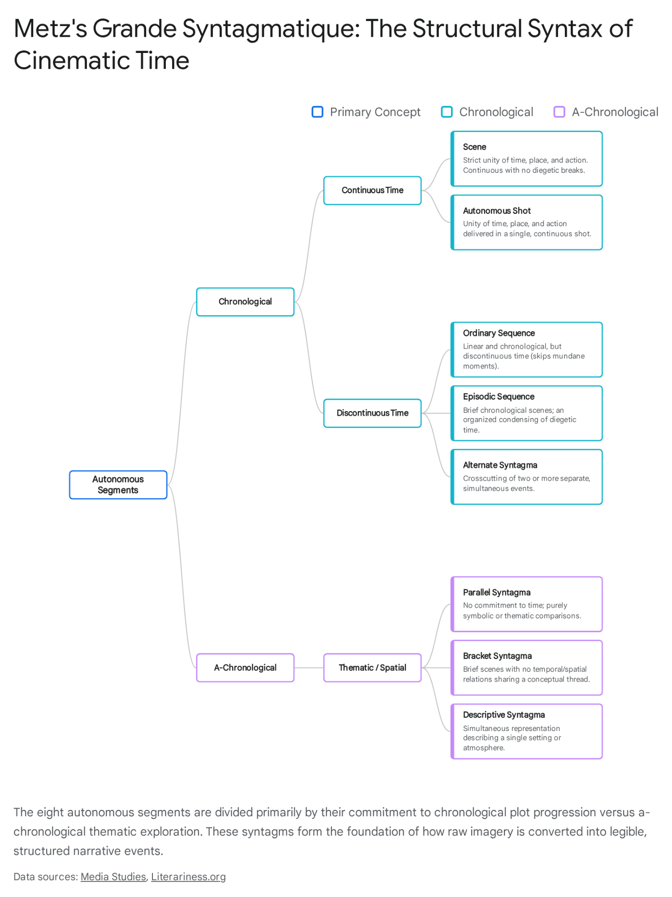

Limitations, Exceptions, and the Paradigmatic Axis
While Metz's grande syntagmatique remains a cornerstone of film semiotics, it is inherently biased toward classical narrative cinema. By identifying the denotative structures common to mainstream commercial filmmaking, Metz successfully isolated the cinema's rhetorical "writing techniques," effectively proving that film could be analyzed with scientific rigor.⁹ However, critics and subsequent post-structuralist theorists noted that this rigid taxonomy prioritizes the syntagmatic axis (the sequential, horizontal ordering of events) to the detriment of the paradigmatic axis (the vertical, associative, metaphorical, or symbolic selection of images).⁹
By attaching his theoretical framework so strictly to a descriptive method meant to examine the denotative level of cinema, Metz's early work left the problems of cinematic connotation, emotional expressivity, and subjective ambiguity relatively untouched.⁹ Furthermore, contemporary film studies have advanced beyond simple syntagmatic categorization, utilizing computational concepts like Average Shot Length (ASL) and algorithmic editing analysis to re-examine Metz's structure.¹⁰ Modern scholars argue that these quantitative approaches foster thinking on the "general" rather than the "particular," often dismissing the "exception" that does not fit the classical editing pattern.¹⁰ Theorists such as Slavoj Žižek and Louis Althusser have articulated the necessity of studying the "exception" (or the "Second Text"), highlighting the irreproducibility of specific stylistic choices that resist broad grammatical categorization—as seen in the unique use of alternation in films like Thelma & Louise.¹⁰ Nevertheless, Metz’s foundational semiotic work laid the indispensable groundwork for understanding how discrete visual components are stitched together to render a continuous, comprehensible reality.

The Ontology of Cineosis: Deleuzian Cinematic Semiosis and the Taxonomy of Images
If Christian Metz successfully mapped the linguistic grammar of narrative cinema, the French philosopher Gilles Deleuze sought to understand the fundamental ontology of the cinematic image itself. Moving aggressively away from linguistic and structuralist analogies, Deleuze positioned cinema not merely as a language of representation, but as a mechanism of philosophical thought—a medium that does not reflect reality, but creates it. In his seminal two-volume work, Cinema 1: The Movement-Image (1983) and Cinema 2: The Time-Image (1985), Deleuze developed an extraordinarily complex taxonomy of cinematic signs.⁶
This dense philosophical taxonomy was built upon the theories of Henri Bergson concerning duration, matter, and memory, crossed with the semiotic triad of the American pragmatist Charles Sanders Peirce.¹² Recently, film philosopher David Deamer synthesized Deleuze's notoriously complex and occasionally ambiguous framework under the neologism "cineosis"—a cinematic semiosis that informs and structures the entirety of Deleuze's project from its first page to its last.⁵ Deamer's exhaustive structural reading sets out to demonstrate how Deleuze's cineosis constitutes a systematically coherent and carefully structured taxonomy from which all individual concepts and cinematic signs unfold.¹¹

The Peircean Foundation and the Movement-Image
In Cinema 1, Deleuze establishes the regime of the "movement-image," rooted directly in Henri Bergson's thesis of movement detailed in his work Matter and Memory.¹² Bergson posits that movement involves an entangled human body and brain situated within a world of matter, where perceptions cause affects, and where affects inevitably cause actions.¹² The body and brain are conceptualized as an accumulation of habitual memories reacting to stimuli.¹² To categorize how classical cinema formally manifests this sensorimotor reality, Deleuze turned to Peirce's three categories of signs.¹²
For Peirce, the basis of semiotics rests on three ontological categories: Firstness (pure feeling or potential), Secondness (reaction or physical actuality), and Thirdness (representation, law, or symbolic habit).¹² Deleuze saw a perfect correspondence between Bergson’s types of images and Peirce’s semiotics: Bergson's "affect" corresponds to Peirce's Firstness; "action" corresponds to Secondness; and "habitual memory" corresponds to Thirdness.¹² However, Deleuze recognized a critical gap in Peirce’s framework regarding pure, unadulterated perception. Consequently, Deleuze introduced the concept of "zeroness" to account for the fundamental perception-image, stating that perception must be assumed as a degree zero from which affection, action, and relation are deduced.¹²
The resulting architecture perfectly aligns Bergson’s sensorimotor arc with Peircean semiotics, creating the four fundamental types of movement-images:

Bergsonian Concept | Deleuzian Cinematic Image | Peircean Semiotic Category | Cinematic Function within the Movement-Image
Perception | Perception-Image | Zeroness | The extraction of a specific body or frame from the totality of worldly images. It isolates a center around which the film's spatial reality will revolve.¹²
Affect | Affection-Image | Firstness (Feeling) | The expression of internal intensive states, feelings, and unfilmable emotions. Often realized visually through the intense close-up of a human face.¹²
Action | Action-Image | Secondness (Reaction) | Focuses on behaviors, physical reactions, and changing the world. Allows the privileged image to act in and upon the spatial environment.¹²
Habitual Memory | Mental-Image / Relation-Image | Thirdness (Representation) | Focuses on the multiplicities of habitual memory, symbolic relations, and the actualization of a character's internal thoughts and dreams.¹²
By applying Peirce's rule that every sign intrinsically possesses three aspects (it is a sign in and for itself; it is a sign in relation to its object; and it must be encountered and interpreted by a mind), Deleuze dramatically expanded the cinematic vocabulary. This multiplication of categories allowed for a complex web of signs, images, avatars, and domains that compose the vast movement-image cineosis, resulting in ten fundamental types of signs.¹²

The Time-Image, Passive Syntheses, and Univocal Multiplicity
The transition from Cinema 1 to Cinema 2 is marked by the collapse of the traditional sensorimotor schema that governed classical Hollywood film.⁶ Following the profound historical and psychological trauma of World War II, a new breed of filmmakers—most notably the Italian Neorealists and Japanese directors like Yasujirō Ozu—began producing cinema where characters could no longer react decisively to their environments.⁶ In the absence of a predetermined action trajectory, the movement-image fails, giving rise to the regime of the "time-image".⁶
Within the time-image, the cineosis transitions into signs that resist the clear differentiation of the movement-image. Deleuze identifies opsigns (pure optical images) and sonsigns (pure acoustical images) where the character is reduced to a passive observer of a world they cannot physically alter.⁶ The time-image delves into profound, non-linear states of memory and duration, featuring hyalosigns (crystal-images where actual present and virtual past time blur indistinguishably), chronosigns, noosigns, and lectosigns.⁶ While Cinema 1 relies on Bergson and Peirce, scholars like D.N. Rodowick and David Deamer note that the impetus for the time-image taxonomy is rooted in the three passive syntheses of time detailed in Deleuze's earlier philosophical masterpiece, Difference and Repetition.⁶ The nine aspects of these passive syntheses correspond directly to the nine proper signs of the time-image, accounting for how cinema can represent time in its pure, unhinged state.¹³
Critics and traditional scholars often view the movement-image and time-image as mutually exclusive regimes, chronologically divided by the advent of post-war cinema.¹¹ However, Deamer’s structural reading of the cineosis abandons these conventional dualistic interpretations. Instead, he posits the two regimes as a "univocal multiplicity"—a heterogeneous system where movement-images and time-images form a kind of Möbius strip of imbrication.¹¹ Rather than a strict division, Deamer demonstrates a sliding scale where time and movement are inherently implicated in one another in every cinematic image, constituting a Spinozan "univocity of being".¹¹ This overarching cineosis proves that cinema functions as a fully realized, standalone semiotic system capable of synthesizing passive and active time, operating through complex connections, interrelations, and exchanges without relying on the written word or human linguistic syntax.¹¹

The Translation to Reality: Sagas, Media Spectacles, and the Narrative Structuring of World Events
If Metz’s syntagms provide the rigid grammar of the sequence, and Deleuze’s cineosis provides the philosophical ontology of the moving image, then the concept of the "saga" represents the socio-cultural application of these cinematic tools to reality itself. In contemporary media theory, the boundary separating fictional entertainment, scripted narrative, and the reporting of actual world events has almost completely dissolved.² The mass media—operating as the dominant controllers of narrative production and consumption in the modern era—utilize cinematic structuring to render chaotic global phenomena legible, often repackaging reality as highly serialized, emotionally driven sagas.²
To understand this phenomenon, one must differentiate between "story" and "discourse" (or narrative). As articulated in analyses of interactive media and board games, "story" represents the conceptual sequence of events that actually happened, while "discourse" is the structure and means of presenting that story to an audience.¹⁶ A story only becomes a functional narrative once it is structured, communicated, and filtered through a specific medium.¹⁶ This distinction gives rise to the concept of the "story-world," a transmedia environment where an accumulated history manifests across a variety of media platforms—whether through scripted narratives delivered via text and video, or emergent narratives created in the minds of the audience.¹⁶

The Fiction Saga: Worldmaking and Historical Integration
In purely fictional media, the saga operates as a sprawling narrative apparatus designed to immerse the consumer. For instance, the comic book series Saga utilizes multi-media effects within a single panel—combining text, image, page layout, and the "gutter" (the space between panels)—to produce an aesthetic experience where readers confront thematic concepts not as mere intellectual debates, but as situated "world events" and alternative possibilities of collective social life.¹⁷ Similarly, the publishing and film industries engineer transmedia marketing campaigns for properties like the Twilight saga, deliberately blurring the lines between consumer and producer.¹⁸ By facilitating online communities and offline real-world events (like fan conventions), the media corporation disguises promotional intent, turning the consumption of fiction into a lived, continuous reality.¹⁸
This blurring of boundaries is profoundly evident in the literary and cinematic "family saga," which uniquely intertwines intimate interpersonal narratives with massive historical world events.¹⁹ Works operating in this genre—such as Herman Wouk’s The Winds of War or contemporary series like Tracks of Our Tears—demand a meticulous level of historical accuracy.¹⁹ The fictional characters are deliberately positioned to interact with, influence, and be subjected to real-world geopolitical shifts and authentic historical figures (e.g., World War II military leaders like General Major von Brauchitsch or Admiral Canaris).¹⁹ The micro-narrative of the family serves as the vital humanizing lens through which the macro-narrative of history becomes emotionally accessible. Consequently, the audience consumes history not as dry facts, but as an immersive, emotionally resonant saga.¹⁹

The Media Spectacle and the Tabloidization of Reality
There is nothing natural or universal about narrative; it is an engineered, historically positioned form of representation designed to structure raw information into formats that are pre-meaningful to their specific audiences.² Theorist Helen Fulton argues that contemporary print and broadcast journalism seamlessly transfers the modes of storytelling developed in classical film and television directly to the reporting of news, resulting in profound ideological implications.²
A primary mechanism of this translation is individualization.² By presenting immensely complex geopolitical, economic, or social events as the direct work of individual people—who are subsequently constructed as conventional cinematic "characters" with stereotyped attributes, recognizable names, and predictable motivations—the media forces real-world events into the familiar syntagmatic structures of a movie script.²
This dynamic sits at the core of what media scholar Douglas Kellner terms the "media spectacle".⁷ Technocapitalism, driven by the imperative to capture audience attention in an infotainment society, generates immense, serialized media extravaganzas that dramatize society's basic values, controversies, and struggles.⁷ Reality is transformed into "megaspectacles"—such as the O.J. Simpson murder trial, the Clinton-Lewinsky sex and impeachment scandal, or the post-9/11 global "Terror War".⁷ The coverage of the Clinton-Lewinsky saga, for example, highlighted the "tabloidization" of news, where serious political discourse was overshadowed by an intense focus on the private, sensational details of public figures.²⁰
These phenomena operate identically to the expanded universes of fictional franchises.²³ A real-world media saga disperses its narrative beats across television breaking news, real-time social media verification platforms, print journalism, internet sites, and eventual authorized docudramas.¹⁸ The logic of the spectacle colonizes everyday life, pacifying the public and proving that the syntactic rules of cinema now absolutely dictate the consumption of reality.⁷

True Crime, Defamation, and Geopolitical Identity
The danger of forcing reality into a cinematic saga is that the real world carries legal, physical, and political consequences that fiction does not. The true crime genre exemplifies this risk. The ongoing legal saga surrounding the television series Baby Reindeer serves as a stark cautionary tale regarding the collision of narrative storytelling and actual world events.²⁵ The viral effect of social media encourages audiences to treat true crime as an interactive saga, often resulting in internet sleuths launching investigative deep dives to uncover the factual basis of the media.²⁵ This leads directly to real-world harm, including the tracking down and "doxing" of real individuals, generating severe risks of harassment, emotional distress, and defamation.²⁵ It underscores the absolute necessity for rigorous fact-checking, carefully worded disclaimers, and the avoidance of overembellishing real events simply to satisfy the pacing requirements of a television syntagm.²⁵
Furthermore, the saga mechanism extends powerfully into nationalistic identity formation and global diplomacy. A prime example is the immensely popular Ip Man martial arts film franchise, a saga co-produced by Hong Kong and Mainland China.²⁶ The narrative trajectory of the Ip Man films seamlessly connects stylized cinematic fiction with real-world historical conflicts, blending the nationalist discourse of 1970s kung fu cinema with officially accepted present-day Chinese nationalism.²⁶ Through the progression of the saga across multiple sequels, the protagonist’s personal struggles are scaled up to represent Chinese tradition defending itself against external threats.²⁶ This functions simultaneously as blockbuster entertainment and as a highly effective vehicle for state-sanctioned soft power.²⁶ The films effectively "other" the West and Japan while constructing a narrative of a benevolent but powerful Chinese self.²⁶ However, this intertwining of fiction and politics is volatile; the release of Ip Man 4 faced severe backlash and boycott calls in Hong Kong from pro-democracy protesters, who accused the producer and star of harboring pro-Beijing sentiments amidst ongoing political crises.²⁶ By merging the immersive properties of the fictional universe with the emotional weight of real history, the saga proves to be an immensely potent, highly weaponized tool for both ideological programming and historical revisionism. The audience consumes the sequence of events not merely as an intellectual debate, but as a situated, felt reality.¹⁷

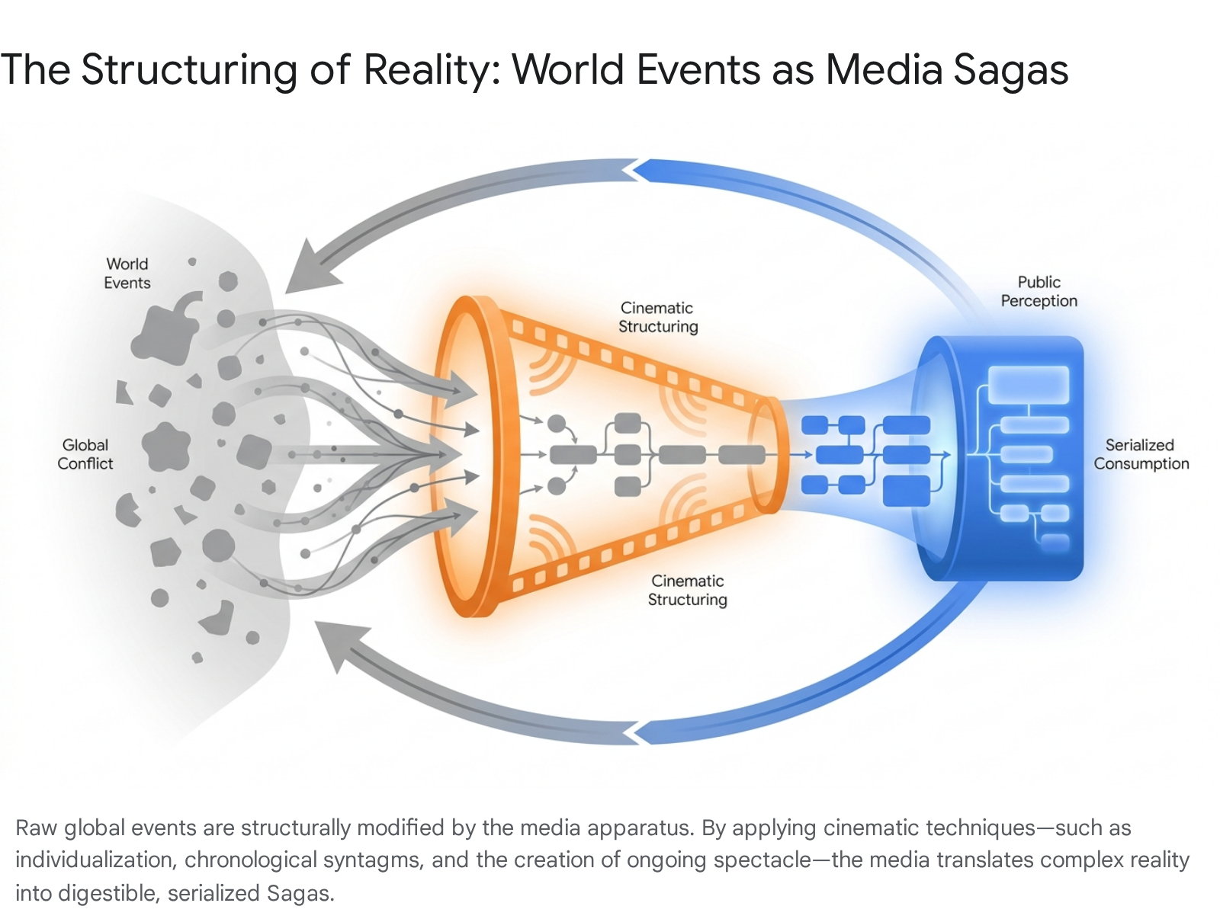

The Post-Human Cinematic Language: Harun Farocki and the Operative Image
For over a century, the grammar of visual media—from Metz’s linguistic syntagms to Deleuze’s philosophical cineosis, and through to the geopolitical framing of the media spectacle—has been predicated on a single fundamental, unquestioned assumption: the image is meant to be seen, interpreted, and emotionally felt by a human being. However, at the dawn of the 21st century, the status and function of the image underwent a radical, irreversible ontological shift. The German filmmaker, theorist, and essayist Harun Farocki identified and named this paradigm-breaking phenomenon the "operative image" (or operational image).⁴

Images Without a Social Goal
In his seminal, three-part experimental audiovisual installation Eye/Machine (2000–2003), Farocki introduced the concept of the operative image as a visualization that serves a purely functional, mechanical purpose rather than an aesthetic or representational one.⁴ Farocki defined operative images as "images without a social goal, not for edification, not for reflection".⁴ Crucially, they do not merely represent an object in the world for a viewer to contemplate; they are an active, integral component of a machinic operation.⁴
Operative images act as "working images"—visualizations of data that actively do work.⁴ One of the most striking examples presented by Farocki in Eye/Machine is the footage captured by a "suicide camera" mounted on the nose of a laser-guided bomb.²⁸ This camera streams visual data to an internal processor specifically to steer the warhead down to its target from above.²⁸ The image becomes more detailed as the missile approaches the ground, and the operation of the camera terminates precisely at the moment of impact and destruction.²⁸ Farocki termed this specific iteration the "phantom-subjective image," as it presents a point-of-view shot belonging not to a human character operating within a narrative syntagm, but to an autonomous, self-terminating algorithm.²⁸

Diagrammatics, Operativity, and the Machinic Agent
The rise of the operative image signifies a monumental shift from the image as a representational device to the image as a machinic agent embedded deeply within systems of automation, simulation, and realization.²⁷ The concept of operativity itself dates back to cyberneticist Norbert Wiener, who used the term to describe the process by which a machine reproduces itself or transfers its operative scheme to another machine.²⁸ In this context, whether the image faithfully reproduces a recognizable visual object is entirely secondary; what matters is that the image correctly performs its intended computational function.²⁸
To fully grasp the scope of this shift, one must understand the connection between operational images and "diagrammatics".³⁰ Theorist Birgit Schneider distinguishes four levels on which diagrams and images become operative:
- Extrinsic Operativity: Where images actively help shape, change, or trigger an external physical process.³⁰
- Cognitive Operativity (Dual): The human cognitive process involved in both the production of the diagrams and the subsequent looking at them.³⁰
- Intrinsic Operativity: The internal, self-contained functional logic of the system itself, where the image is entirely absorbed in a technical execution.³⁰
Today, intrinsic operativity is ubiquitous. Operational images operate planetary-scale interfaces, governing weapons targeting and guidance systems, assisting surgeons performing highly delicate robotic surgery, conducting automated quality control inspections in industrial factories, and performing optical character recognition on license plates for mass surveillance.⁴ Operativity in this context cannot be understood as either strictly human or strictly non-human agency; it is multi-layered, relational, and deeply interdependent.³⁰
In these contexts, human perception is entirely secondary, or even obsolete. The image exists so that a machine can "see" and "act." However, as contemporary scholars and artists like Trevor Paglen note, these images are frequently intercepted, redirected, and repurposed for human interpretation, creating a secondary redeployment in contemporary visual culture.²⁷ Here, the human observer attempts to decipher the alien logic of algorithmic machine vision.²⁷ Artists are actively attempting to reclaim human agency within this space. For instance, the artwork Terms and Conditions, co-created by Ruti Sela and researchers, examines how artistic gestures and "operative creativity" might actively neutralize the weaponized gaze, troubling machinic vision to reclaim a space for human opacity in an age of total surveillance.²⁷
This intrinsic operativity fundamentally redefines the boundaries of classical semiotics. The signifier and the signified collapse into pure mathematical function. The image no longer means something; it does something.³⁰ Operative images replace the spectator with an algorithm, rendering Metz’s theories of psychological sequence and Deleuze’s sensorimotor arcs fundamentally incompatible with machinic ontology.

The Genesis of Algorithmic Visual Execution: BEFLIX and the Automation of the Pixel
While Harun Farocki brilliantly articulated the socio-political philosophy of the operative image in the early 2000s, the technical foundation for algorithmic visual execution was laid decades earlier in the laboratories of mid-century corporate research. The transition from the hand-drawn, physically captured image (the domain of traditional cinema) to the mathematically computed, autonomous visual space began in the early 1960s with the invention of specialized programming environments designed strictly for computer animation.³

The Invention of BEFLIX at Bell Labs
In 1963, Kenneth C. Knowlton, a pioneering researcher working at Bell Telephone Laboratories in Murray Hill, New Jersey, developed BEFLIX (a portmanteau of "Bell Flicks").³ BEFLIX is widely recognized by computer scientists and film historians as the first embedded domain-specific language (DSL) explicitly designed and engineered for the generation of computer animation and bitmap-based movies.³ Knowlton’s invention was a watershed moment in the history of visual execution; it enabled the creation of moving images not by exposing film stock to light through a camera lens, but by specifying frames through a sequence of algorithmic subroutines that handled image rendering on primitive computing hardware.³¹
The primary, initial purpose of BEFLIX was highly utilitarian: to automate the generation of animations for educational purposes and complex engineering simulations.³ By leveraging programmed instructions to generate sequences of bitmap frames, scientists could bridge the gap between rigorous computational methods and visual explanation, illustrating abstract concepts in physics and research visualizations with unprecedented precision.³¹ However, the application of BEFLIX quickly expanded into highly experimental artistic realms. Between 1966 and 1969, Knowlton collaborated closely with the experimental filmmaker and artist Stan VanDerBeek to produce the Poemfields series (comprising approximately eight films).³ These films demonstrated that programmed instructions could seamlessly blend computational rigor with visual poetry, establishing foundational techniques for computer-generated imagery (CGI) that would eventually influence all modern film and digital art.³¹

The Technical Mechanics of Early Visual Execution
The technical execution of BEFLIX offers a fascinating, granular glimpse into the primordial state of digital image manipulation. The language was initially developed as an embedded system within a FORTRAN II implementation, utilizing FORTRAN II Assembly Program (FAP) macros on the massive IBM 7090 mainframe computer.³ A later version targeted FORTRAN IV, operating more like a traditional subroutine library, though it lost some of the unique syntactic flavor of the original language.³
Because computers at the time lacked modern graphical displays, BEFLIX outputted its graphics to a Stromberg-Carlson SC4020 microfilm plotter.³ The SC4020 was originally designed for plotting simple data graphs and exposing microfilm via a charactron tube.³ It lacked the innate hardware ability to draw continuous, high-resolution film-sized characters or images.³² Knowlton bypassed this severe hardware limitation with a stroke of genius: he purposefully defocused the electron beam of the charactron tube, using the blurred character shapes to draw discrete grayscale pixels.³ Characters were carefully selected to create an 8-level range of grayscale values (from 0 for black to 7 for white).³
The memory of the IBM 7090 was organized into rectangular surfaces consisting of a pixel raster.³ The system allowed for two primary output resolutions optimized for the plotter: a "fine" mode consisting of 252 x 184 pixels, and a "coarse" mode of 126 x 92 pixels.³ Because the pixel values only ranged from 0 to 7, they could be packed highly efficiently—12 pixels into a single 36-bit word of the mainframe's memory.³ BEFLIX also featured a preview mode, allowing selected frames to be written to a standard line printer for review before committing to the magnetic tape that communicated with the external film recorder.³

The Syntax of Algorithmic Space: The 26 Scanners
The defining innovation of BEFLIX was its operational logic, which relied entirely on a set of 26 programmatic "scanners," named simply A through Z.³ These scanners acted as autonomous read/write heads that could move independently across the 2D coordinate surface of the input information.³
Programming in BEFLIX involved writing a series of highly specific conditional statements on punched cards. The core command structure followed a strict syntactic logic: (scanner, operator, scanner or number).³² Depending on the operator used, this element could act as a condition (a test) or an action.³² The general form of a BEFLIX instruction was: IF... (condition)...(condition) T (action)...(action) LABEL.³² Programmers would write instructions that tested the relative positions or values of the scanners, and if the conditions were met, executed instantaneous pixel manipulations.³² This concept of scanners traversing a spatial grid to process distributed information was so novel that Knowlton secured US Patent 3,609,670 for the system.³²

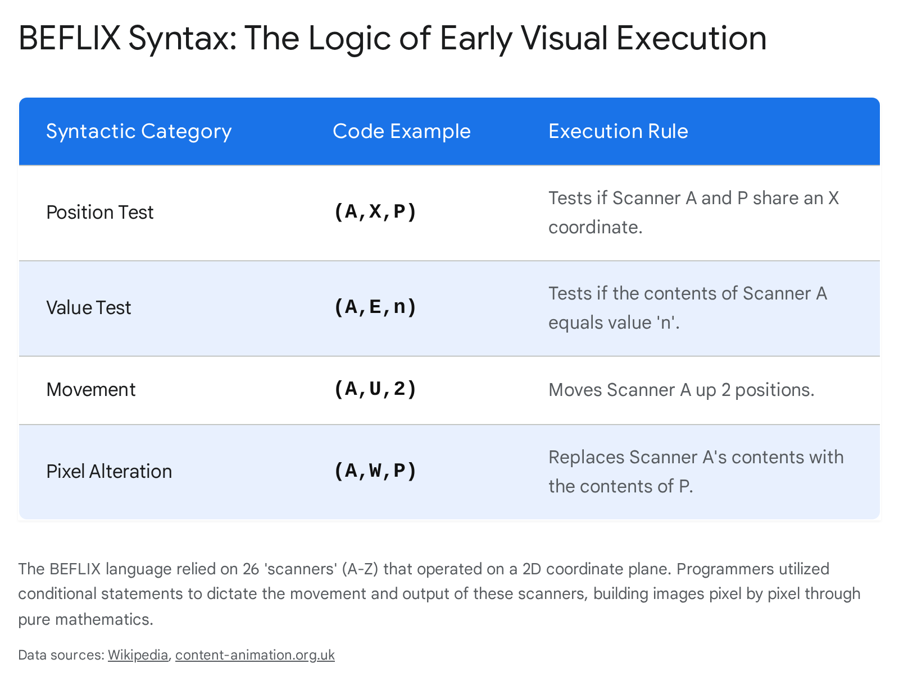

For example, a low-level operation to manipulate pixels might be coded as: IFANY (B,R,10)(B,A,C)(A,E,7)T(A,T,B)(A,U,2)(A,W,3)LOC5.³ Translated from raw mainframe code into cinematic action, this instruction dictates that if any of three conditions are true (if scanner B is to the right of the x-coordinate 10, OR if scanner B is above scanner C, OR if the pixel value at scanner A is exactly 7), then three actions must occur: scanner A moves to the exact surface position of scanner B, scanner A moves up exactly two rows, and scanner A writes the grayscale value of 3 into that pixel.³ Finally, control passes to the next operation labeled LOC5.³ Pixel values could also be inverted via complement commands, or arithmetically combined through addition or logical AND/OR operations.³¹
Through these intricate logical operations, incredibly complicated visual patterns and movements could be programmed into the behavior of the 26 scanners.³ These low-level, instantaneous scanner operations updated the surface rasters without outputting a frame in between.³ Only when the surface was fully drawn would a high-level operation command the system to output the picture to magnetic tape.³ High-level operations also included rendering basic drawing primitives (lines, arcs, curve plots, and text) and performing dynamic operations on rectangular areas, which could be executed incrementally over a series of frames to quickly encode smooth animations.³
The scanner-based raster approach of BEFLIX was considered highly original and superior in many ways to contemporary alternatives. Other early animation systems, such as GROATS, attempted to define outline fonts, while ANTICS produced characters by drawing dense sets of parallel lines to fill in shapes—a method that was computationally costly and visually unstable due to the difficulty of maintaining constant line separation.³² In BEFLIX, the image was no longer a captured reflection of light acting on chemical celluloid; it was an architecture of pure mathematical logic. By rendering visuals through conditional algorithmic statements, Knowlton established the technological bedrock for the modern operative image. The alphanumeric scanners of BEFLIX were the primitive, mid-century ancestors of the highly advanced, autonomous algorithms that now drive machinic vision across the globe.

Conclusion
The architecture of cinematic meaning is demonstrably not a static or natural phenomenon; it is a continuously evolving spectrum of syntactic logic, philosophical synthesis, narrative framing, and, ultimately, computational execution. In the mid-twentieth century, Christian Metz demonstrated that the filmic sequence constructs an "impression of reality" through the strict temporal rules of the syntagm, effectively teaching audiences how to read and decode sequential imagery. Subsequently, Gilles Deleuze and David Deamer's profound concepts of cineosis elevated this structural grammar, proving that cinema acts as an independent philosophical apparatus capable of expressing the deepest complexities of time, action, and human memory.
As these powerful tools of representation permeated the global consciousness, mass media conglomerates effectively weaponized them. Raw world events and chaotic historical crises are no longer experienced objectively; they are processed, individualized, and packaged into serialized sagas and massive media spectacles. These spectacles rely entirely on the cinematic syntagms of pacing, characterization, and narrative tension to enforce specific ideological realities and geopolitical identities upon the viewing public.
Yet, the ultimate historical trajectory of visual media points decisively away from human interpretation. The advent of BEFLIX in the early 1960s severed the moving image from the physical camera lens, reducing visual execution to coordinate matrices, defocused electrons, and conditional logic loops. This computational foundation paved the way for Harun Farocki’s operative image—the current, unsettling paradigm where images act autonomously within weapon systems, industrial algorithms, and planetary-scale surveillance networks. From the carefully constructed narrative syntax of the film reel to the cold, non-human logic of machine vision, the moving image continues to rapidly reshape not only how reality is represented, but how reality is fundamentally executed.

Works cited
- Christian Metz and the Grand Syntagma of Cinema - Media Studies, accessed June 9, 2026, https://media-studies.com/grand-syntagma/
- Narrative and Media, accessed June 9, 2026, https://www.philol.msu.ru/~discours/images/stories/speckurs/Narrative_and_media.pdf
- BEFLIX - Wikipedia, accessed June 9, 2026, https://en.wikipedia.org/wiki/BEFLIX
- Operational image - Wikipedia, accessed June 9, 2026, https://en.wikipedia.org/wiki/Operational_image
- Preface: a Deleuzian cineosis - Deleuze's Cinema Books - Cambridge University Press & Assessment, accessed June 9, 2026, https://www.cambridge.org/core/books/deleuzes-cinema-books/preface-a-deleuzian-cineosis/8493AA727E5755A6A268A0BF3DFFFFCE
- Cinema 2: The Time-Image - Wikipedia, accessed June 9, 2026, https://en.wikipedia.org/wiki/Cinema_2:_The_Time-Image
- Media Spectacle by Douglas Kellner - UCLA School of Education & Information Studies, accessed June 9, 2026, https://pages.gseis.ucla.edu/faculty/kellner/papers/mediaspectacleintro.htm
- Christian Metz and Film Theory, accessed June 9, 2026, https://literariness.org/2018/03/20/key-theories-of-christian-metz/
- CINEMA AS SIGN AND LANGUAGE - Journal Publishing Service, accessed June 9, 2026, https://journals.uvic.ca/index.php/ctheory/article/view/13905/4678
- A Re-reading of Christian Metz's “Grande Syntagmatique” Through the Concept of “Exception”, accessed June 9, 2026, https://ynu.repo.nii.ac.jp/record/9030/files/4-1-4.pdf
- David Deamer (2016)Deleuze'sCinemaBooks: Three Introductions to the Taxonomy of Images - ResearchGate, accessed June 9, 2026, https://www.researchgate.net/publication/317326491_David_Deamer_2016Deleuze'sCinemaBooks_Three_Introductions_to_the_Taxonomy_of_Images
- Cinema 1: The Movement Image - Wikipedia, accessed June 9, 2026, https://en.wikipedia.org/wiki/Cinema_1:_The_Movement_Image
- A Deleuzian Cineosis: Cinematic Semiosis and Syntheses of Time | Deleuze Studies, accessed June 9, 2026, https://www.euppublishing.com/doi/abs/10.3366/dls.2011.0026
- David Deamer (2016) Deleuze's Cinema Books: Three Introductions to the Taxonomy of Images | Film-Philosophy - Edinburgh University Press Journals, accessed June 9, 2026, https://www.euppublishing.com/doi/10.3366/film.2017.0048
- Movement-images: Peirce, semiosis (Chapter 2) - Deleuze's Cinema Books, accessed June 9, 2026, https://www.cambridge.org/core/books/deleuzes-cinema-books/movementimages-peirce-semiosis/9230BADB905FB0CE7E97F8618512151F
- Design Diary 2 – Boardgame Narrative - Mighty Boards Design Blog, accessed June 9, 2026, https://mighty-boards.blog/design-diaries/design-diary-2-boardgame-narrative/
- Worldmaking, Legal Education, and the Saga Comic Book Series - PMC, accessed June 9, 2026, https://pmc.ncbi.nlm.nih.gov/articles/PMC8454014/
- View of Industries, artists, friends and fans: Marketing young adult fictions online, accessed June 9, 2026, https://firstmonday.org/ojs/index.php/fm/article/view/2443/2160
- What It Means to Qualify as a Family Saga: The Depth and Detail Behind the Genre, accessed June 9, 2026, https://www.tracksofourtears.com/blog/what-it-means-to-qualify-as-a-family-saga-the-depth-and-detail-behind-the-genre
- News as Narratives - ResearchGate, accessed June 9, 2026, https://www.researchgate.net/publication/405916270_News_as_Narratives
- Media Spectacle by Douglas Kellner - UCLA School of Education & Information Studies, accessed June 9, 2026, https://pages.gseis.ucla.edu/faculty/kellner/papers/mspreface.htm
- Kellner (2004) “Media Culture & the Triumph of the Spectacle” - Le Moyne, accessed June 9, 2026, https://web.lemoyne.edu/~hevern/psy355_26S/psy355documents/Kellner_(2003).pdf
- Expanded universe - Grokipedia, accessed June 9, 2026, https://grokipedia.com/page/Expanded_universe
- Stay Updated with the Latest Breaking News Around the World - Maurilog, accessed June 9, 2026, https://maurilog.com/news/stay-updated-with-the-latest-breaking-news-around-5/
- Of Rudolph... sort of... defamation and the Baby Reindeer saga - Arts Law Centre of Australia, accessed June 9, 2026, https://www.artslaw.com.au/of-rudolph-sort-ofdefamation-and-the-baby-reindeer-saga/
- China's Push for Greater Influence in the Popular Culture Arena: The Ip Man Saga - UTUPub, accessed June 9, 2026, https://www.utupub.fi/bitstreams/c04e31b3-ee32-4989-abfe-3c03b1b7628c/download
- Operative Creativity: Art at the Intersection of Simulation and Realization - MDPI, accessed June 9, 2026, https://www.mdpi.com/2076-0752/14/5/99
- Operative Images - Aerial Spatial Revolution, accessed June 9, 2026, https://aerialspatialrevolution.ch/operative-images
- Working images: Harun Farocki and the operational image - ResearchGate, accessed June 9, 2026, https://www.researchgate.net/publication/345738562_Working_images_Harun_Farocki_and_the_operational_image
- WHICH OPERATIV- ITY? ON POLITICAL ASPECTS OF OPER- ATIONAL IMAGES AND SOUNDS - Heidelberg University, accessed June 9, 2026, https://ahnp.ub.uni-heidelberg.de/journals/ic/article/view/93406/89929
- BEFLIX - Grokipedia, accessed June 9, 2026, https://grokipedia.com/page/BEFLIX
- BEFLIX - Content: Animation, accessed June 9, 2026, https://www.content-animation.org.uk/animation_systems/beflix.htm
- Computer Film as Film Art - Luxonline, accessed June 9, 2026, https://www.luxonline.org.uk/articles/computer_film(1).html

